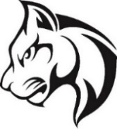

The place you want to be
Passion – Positivity – Pride - Performance

Advisory Council
1/14/25

- 5:30 – 5:40 SACI Report
- 5:40 – 6:10: Discipline & PWCS’ Code of Behavior
  - Beliefs on Discipline and our Discipline Plan
  - PWCS’ Code of Behavior
    - Families as Partners
    - Acts for which students may be disciplined
    - School Bus Rules
      - Transportation Regulation: https://go.boarddocs.com/vsba/pwcs/Board.nsf/goto?open&id=BL25H41045B1#
    - Tiered Responses to Student Behavior
      - Restorative Discipline
- 6:15 – 6:30: Open Topic/Discussion
  - Lunch Line & Clubs (from previous meeting)
- Next Meeting: March 11th – No Meeting in February
  - Input on the next topic to cover?

