

The place you want to be
Passion – Positivity – Pride - Performance

Advisory Council
11/19/24

- 5:30 – 5:40 SACI Report
- 5:40 – 6:00
  - Pattie’s Student Achievement (2023-2024)
  - Pattie’s Data relating to Commitments #2 and #3
    - Positive Climate and Culture
    - Family Engagement
- 6:00 – 6:15 – Pattie’s Continuous Improvement Plan
  - Goal: 90% pass rate in Reading – All Students
    - 100% of classroom observations will reflect evidence of teaching, modeling or holding students accountable for engaging with text they are reading
  - Goal: 87% pass rate in Science – All Students (5th grade)
    - 100% of classroom walkthroughs in 4th and 5th grades will reflect evidence of students applying their understanding of concepts in science by working at the “Apply” level or higher of Bloom’s Taxonomy.
  - Goal: 50% or fewer of 4th and 5th graders will report being bullied on social media
    - Increase parent outreach and knowledge
    - Teach students how to handle online bullying
  - Goal: 25% reduction of K-1 families identified as Tier 2 or Tier 3
    - Proactive outreach to identified families to ensure that they understand the impact of their child’s absences, their child’s grades and current achievement, and their attendance at important school events with regards to their student’s achievement.

- 6:15 – 6:30 - Questions and Open Comment
- Next Meeting: January 14th
  - Input on the next topic to cover?

Overall Ranking (out of 62 ES) Overall SOL Achievement
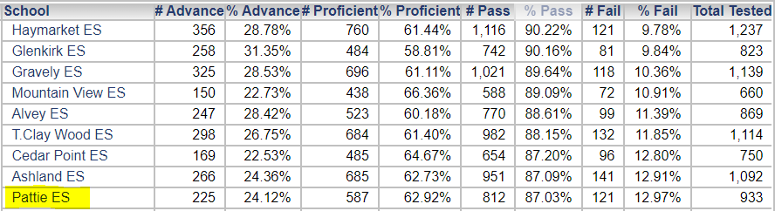

Overall Ranking (out of 62 ES) Math SOL Achievement
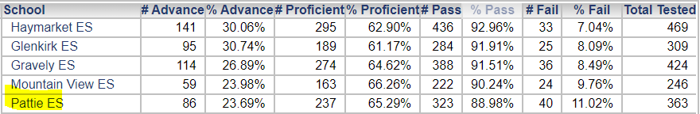

Overall Ranking (out of 62 ES) Reading SOL Achievement
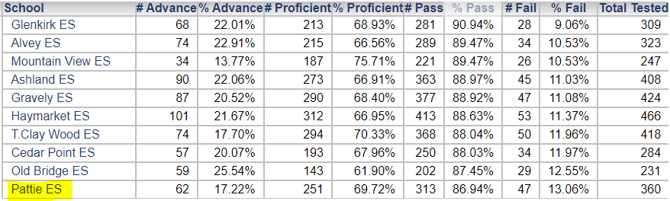

Overall Ranking (out of 62 ES) Science SOL Achievement
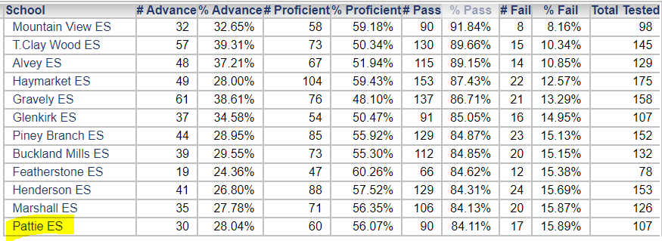

Overall Ranking (out of 62 ES) Virginia Studies SOL Achievement
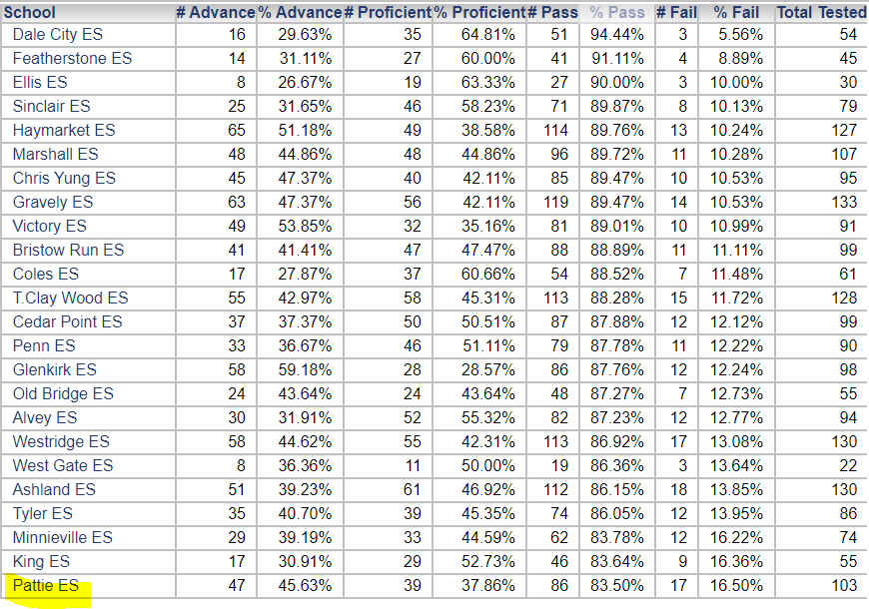

Overall Ranking (out of 62 ES) SOL Achievement – ESOL

Overall Ranking (out of 62 ES) Math & Reading Achievement – ESOL
Math
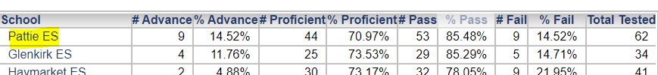
Reading
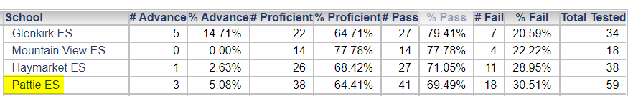
Overall Ranking (out of 62 ES) SOL Achievement – Special Education
